Portfolio:
- Fix holding names.
  - For example:
    - 0P000125KV.L should be Fidelity Index World Fund
    - 0P000102LY.L should be L&G European Index C Acc
    - 0P0001O7DK.L should be iShares UK Equity Index (UK) S Acc
    - 0P0001O7DL.L should be iShares Pacific ex Jpn Eq Idx (UK) S Acc
  - To test:
    - 0P0000WN7J.L – HSBC European Index Accumulation C
    - 0P0001FIOP.L – Fidelity Index US P GBP Acc H
    - 0P000125KU.L – Fidelity Index US Fund
    - 0P000125KT.L – Fidelity Index UK Fund
- Add stock market (e.g. LSE, Nasdaq, NYSE, etc.).
  - So the format of the Name / Symbol column should be this:
    - Name in big.
      - Below in subscript: Ticker | Market.
        - Vanguard S&P 500
_{VUSA.L | LSE}
- Fix small problem with pie charts at the bottom. When you switch from Bars to Pie, the size of the box increases ever so slightly, which aesthetically is a bit off-putting. Not a big deal at all; I’m just nitpicking here.

Watchlist:

Research:
Code in a investment report creator maybe.

- Pre-Earnings Movers.
- Big Movers (with explanation why).

Stock rating (pull from as many sites as possible; find these sites).
Per-source matrix with rating, target, analyst count, last-updated
Pre-earnings movers — screen of what reports this week across your universe
Big movers with attribution — the move plus the likely cause
Business explainer — what it makes, who buys it, in four sentences
"What the market currently believes" as an assumption, not a rating
ETF view — holdings, top-10 weight, expense ratio, flows, tracking error
Index view — breadth, constituent movers, aggregate valuation
Investment report generator — one-page PDF from the current view

Pages:
- Main Page:
  - At the top of page: small search bar to put the ticker. However, it shouldn’t be the width of the page, as it will just be 90% empty. Next to it, Analyse button.
  - Directly below the search bar is the main box that displays the key information/stats about the stock/company.
    - Formatted well, it shows the name, price, performance chart, and more.
  - Below that, a fundamentals box.
- Bull vs Bear Page.

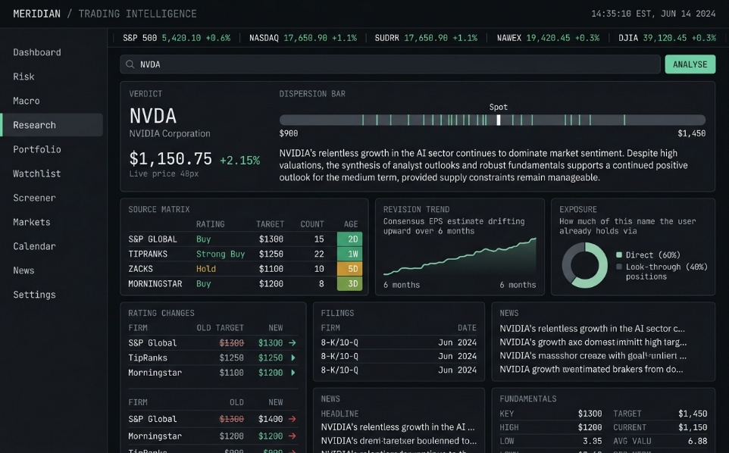
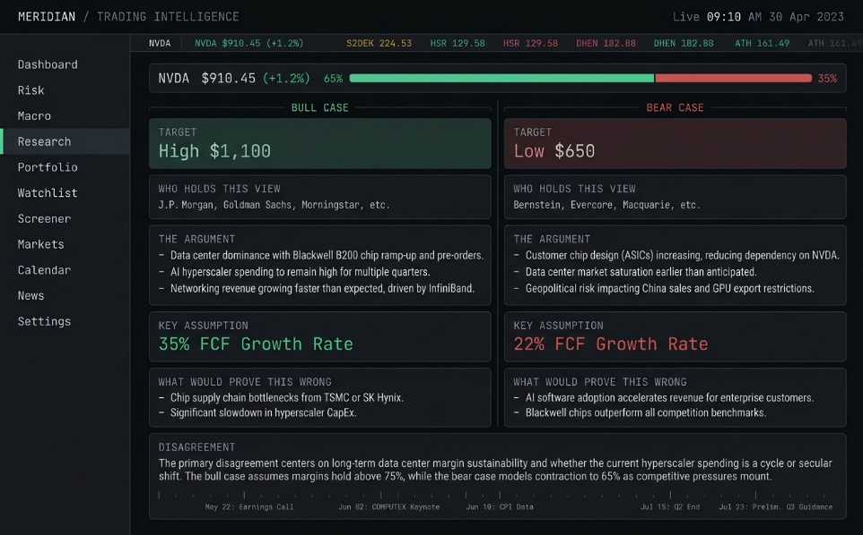

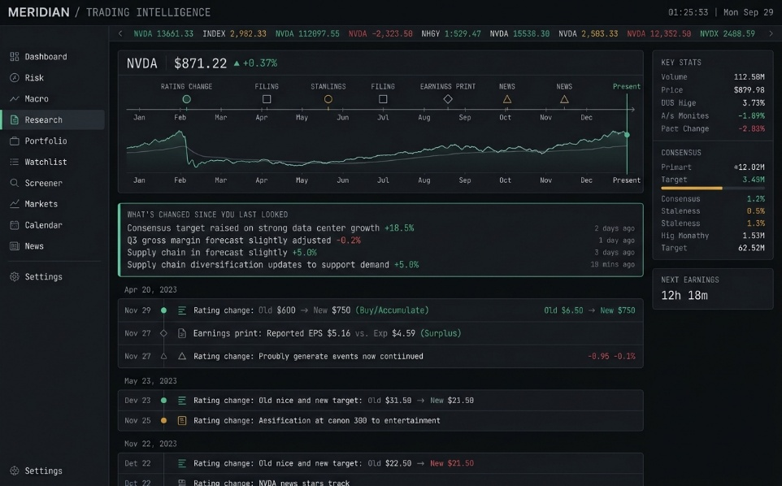

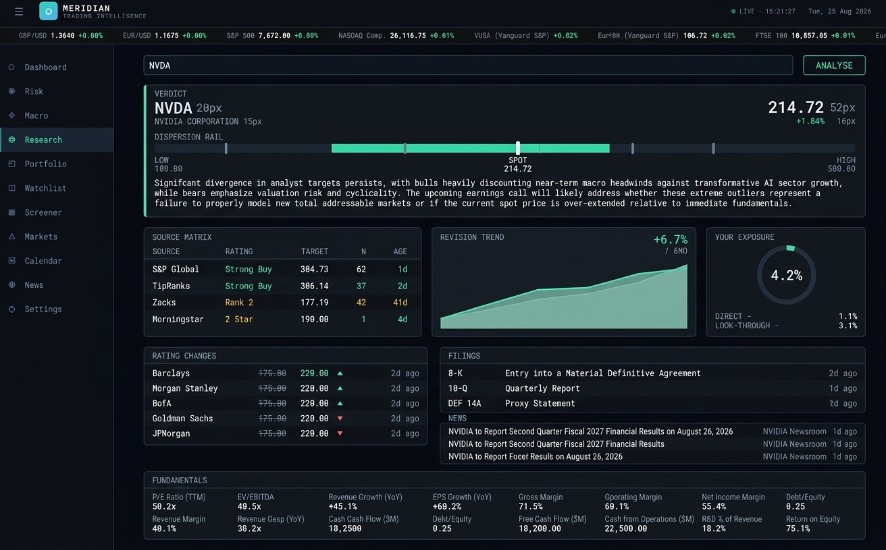

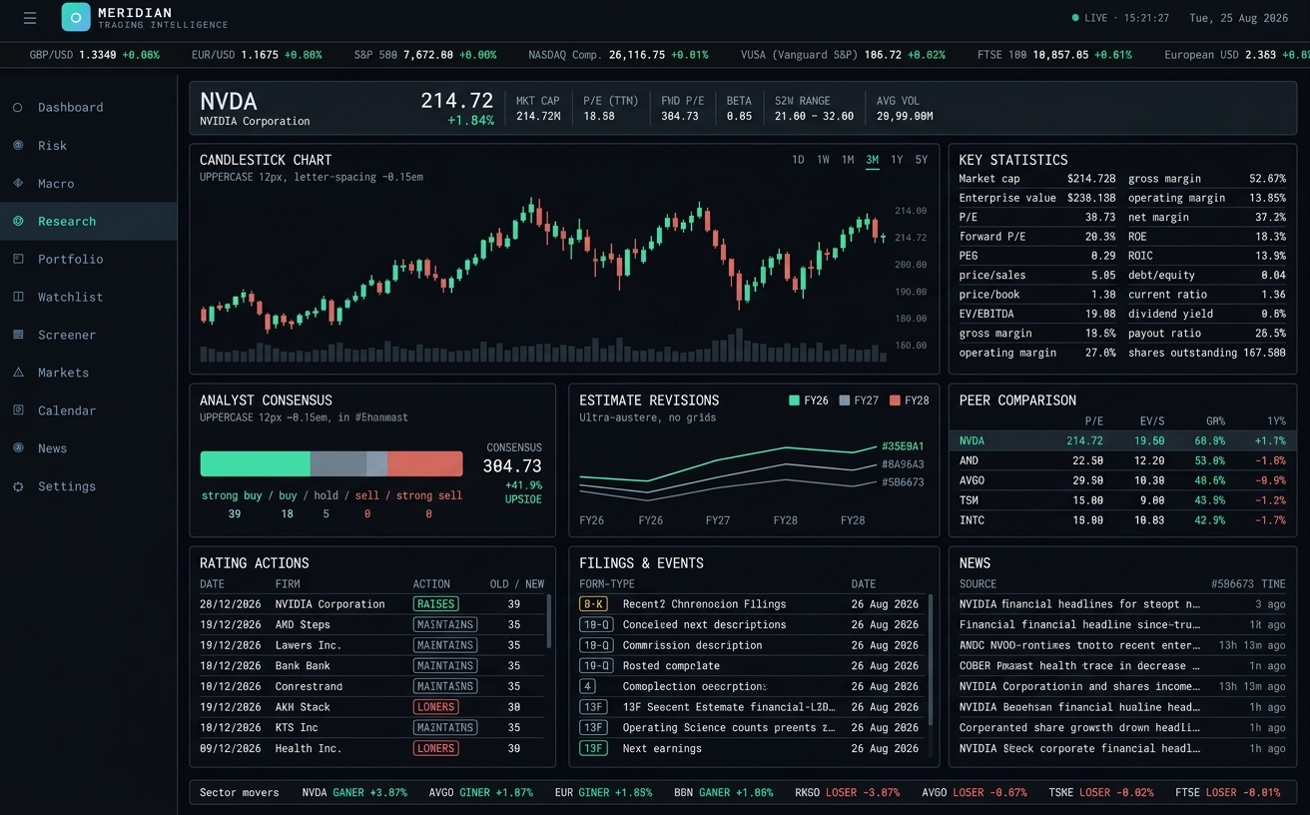

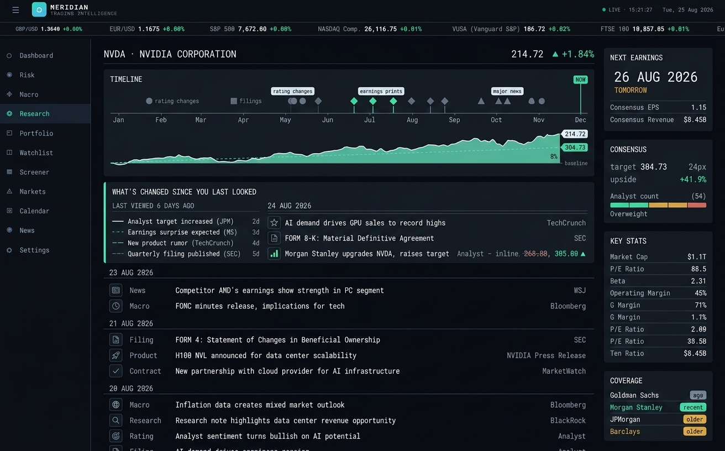
News:
Could be folded into dashboard main page.

Risk:
Could be a sub-page in portfolio page.

Calendar:

Markets:
- Get crypto prices.
- Widen FX coverage.

